**JVM, JRE and JDK**

**JVM (JAVA Virtual Machine):-**

1. It is a part of JRE.

2. It’s main function is to convert byte code to the machine code.

3. It is platform dependent.

4. It does not exists physically.

5. It provides the environment in which byte code can be executed.

6. It loads the byte code, verifies the byte code and executes it.

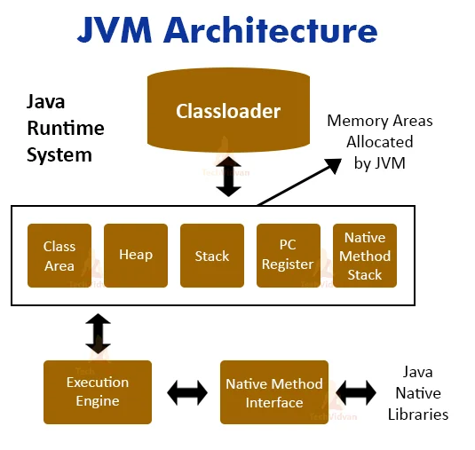**Classloader:-**

Classloader loads the program into memory for execution. It is responsible for loading .class files.

**Class area:-**

It is also known as method area. It store the information about method such as method name, code of the method.

**Heap area:-**

It is used to store the object.

**Stack area:-**

It is used to store information about local variable.

**PC register:-**

It contain the address of instruction which is currently executing.

**Native method stack:-**

It include native method information.

**Execution engine:-**

It includes JAVA interpreter, JIT (Just In-Time compiler).

**JIT:-**

The Just-In-Time (JIT) compiler is a component of the Java Runtime Environment that improves the performance of Java applications at run time. The JIT compiler helps improve the performance of Java programs by compiling bytecodes into native machine code at run time.

**JAVA native libraries:-**

Java Native Library is the collection of Native methods which are required in java. Native method is a method declared in java but,implemented in non java programming languages like C, C++etc.

⁠

**JAVA native interface:-**

It is responsible for communication between execution engine and JAVA native libraries. It allows Java code that runs inside a Java Virtual Machine (VM) to interoperate with applications and libraries written in other programming languages, such as C, C++, and assembly.

**JRE:-**

It is nothing but JAVA runtime Environment.

It consist of JVM, core classes and supporting files.

**JDK:-**

It is nothing but JAVA Development Kit. It consist of JRE and various development tools such as JAVA compiler, documentation generator.

